Test Documentation

User Story 3 | As an Admin, I want to be able to login, so that I can view the website
Test Case ID | 3
Description | Login
Preconditions | - Apache is running  - The browser is open  - The database is available
Actions | - The address ‘http://localhost/Cosmere/public/login.php’ is entered in the browser  - Valid information is entered
Expected Results | - The page loads  - The home page is displayed
Test Status | Passed

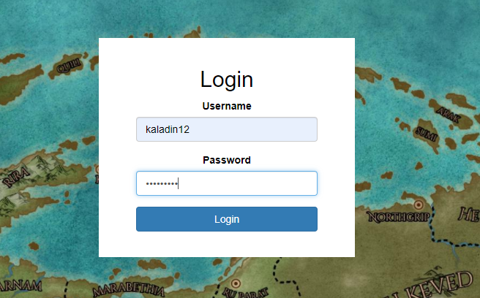


User Story 2 | As an Admin, I want to be able create a book, so that I can add new books for my customers to look at
Test Case ID | 2
Description | Create a book
Preconditions | - JApache is running  - The browser is open  - The database is available
Actions | - The address ‘http://localhost/Cosmere/public’ is entered in the browser  - The ‘Create’ link is clicked  - Fill in the information
Expected Results | - The page loads  - The Book section is displayed with the new book present
Test Status | Passed

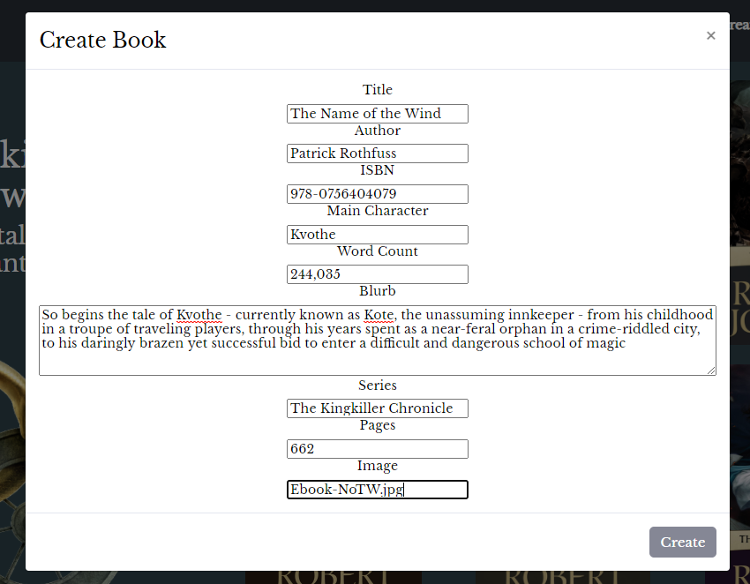


User Story 4 | As an Admin, I want to be able to logout, so that I stop someone using the website while I’m gone
Test Case ID | 4
Description | Logout
Preconditions | - Apache is running  - The browser is open  - The database is available  - You are logged
Actions | - The address ‘http://localhost/Cosmere/public/’ is entered in the browser  - Open the dropdown profile  - Click on logout
Expected Results | - The login pages opens
Test Status | Passed

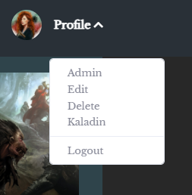

User Story 5 | As an Admin, I want to be able to edit my information, so that I can keep my account up to date
Test Case ID | 5
Description | Edit the current user
Preconditions | - Apache is running  - The browser is open  - The database is available  - The user is logged in
Actions | - The address ‘http://localhost/Cosmere/public/’ is entered in the browser  - Open the profile dropdown  - Click edit  - Fill in the modal and click save
Expected Results | - The page loads  - The resulting profile bar has been updated
Test Status | Passed

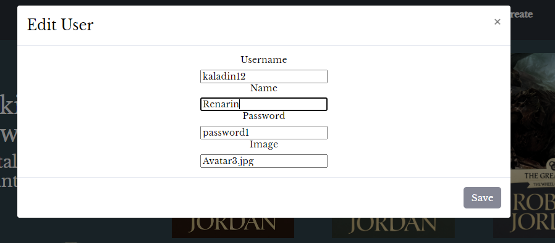
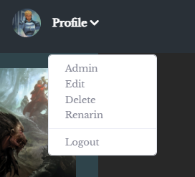

User Story 6 | As an Admin, I want to be able to edit a books information, so that I can keep all books up to date with new versions
Test Case ID | 6
Description | Edit a book
Preconditions | - Apache is running  - The browser is open  - The database is available
Actions | - The address ‘http://localhost/Cosmere/public/’ is entered in the browser  - Click on a book  - Click on the edit button in the card  - Fill in the modal and click save
Expected Results | - The page loads  - The resulting book information has changed
Test Status | Passed

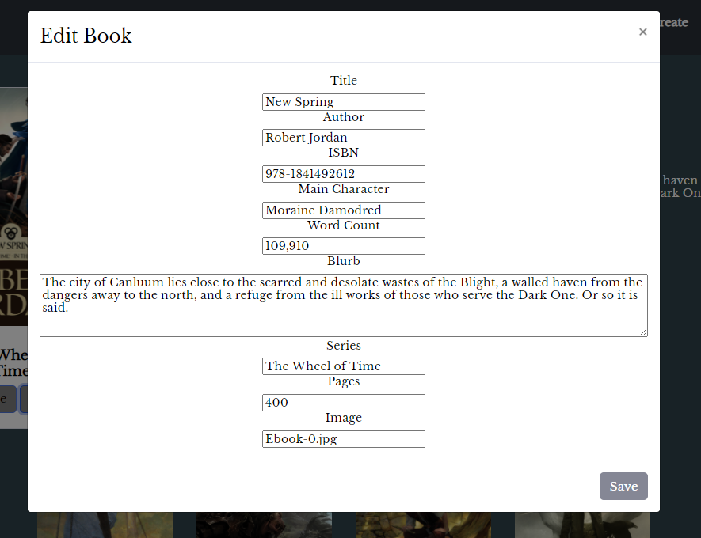
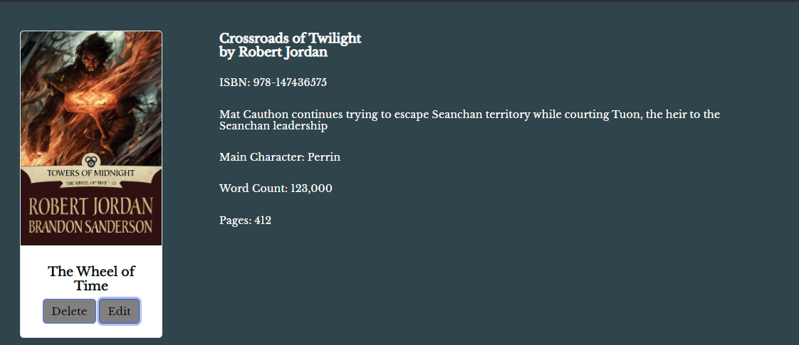

User Story 7 | As an Admin, I want to be able to delete a book, so that I can remove old books
Test Case ID | 7
Description | Delete a book
Preconditions | - Apache is running  - The browser is open  - The database is available  - User logged in
Actions | - The address ‘http://localhost/Cosmere/public/’ is entered in the browser  - Click on a book  - Click on the delete button
Expected Results | - The page loads  - The page loads with the book gone
Test Status | Passed



User Story 8 | As a User, I want to be able to delete my account, so that if I don’t user the site my information is gone
Test Case ID | 8
Description | Delete my account
Preconditions | - Apache is running  - The browser is open  - The database is available  - User logged in
Actions | - The address ‘http://localhost/Cosmere/public/’ is entered in the browser  - The account dropdown is open  - Click on delete
Expected Results | - The page loads  - Account is deleted from database
Test Status | Passed

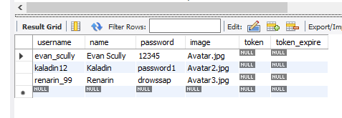
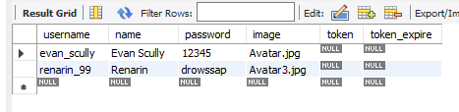

User Story 9 | As a User, I want my information to display, so that I can see my account information
Test Case ID | 9
Description | Get my information
Preconditions | - Apache is running  - The browser is open  - The database is available  - User is logged in
Actions | - The address ‘http://localhost/Cosmere/public/’ is entered in the browser  - The profile link is clicked
Expected Results | - The page loads  - A dropdown opens up with actions and information
Test Status | Passed

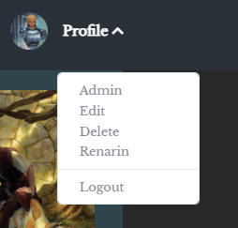

Test Report Summary

Test Type | Number Passed | Number Failed
Manual | 10 | 0

Bug Report
There are currently no known existing bugs in this project.

